hyper-parameter optimization project

Authors: Mohammadjavad Abbas pour & Ahmad Yazdani

Supervisor: Dr.Taheri

Optimization in data science

Shahid Beheshti University

July , 2022

**Abstract**

This project is a hyper-parameter-optimization of the neural network, which has been implemented on Bace molecular data set . I use ray , pytorch ,schedulers and search-algorithms and more objects in this project.

## Introduction of dataset

## Type of data set is molecular. The number of records is 1513 , target variables are 0 or 1 and the number of features is 200.

## Distribution of labels plot:

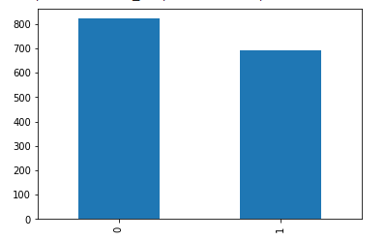

In this case the distribution of labels are balance. There is an balance between the class of one and zero labels in Bace dataset.

## Preprocessing

Data partitioning, Feature selection, and Missing are the important things for prepare the data for final processing.

**Import libraries**

%%capture

try:

    import ray

except:

    !pip install -U ray

    import ray

try:

    import optuna

except:

    %pip install optuna

    import optuna

    %%capture

try:

    from featurewiz import featurewiz

except:

    !pip install featurewiz==0.1.70

import numpy as np

import pandas as pd

import torch

import torch.nn as nn

from torch.utils.data import TensorDataset

from pandas import read_csv

from sklearn.impute import SimpleImputer

import io

import matplotlib as mpl

import matplotlib.pyplot as plt

import random

from functools import partial

import os

import torch.nn.functional as F

import torch.optim as optim

from torch.utils.data import random_split

from torchsummary import summary

from ray import tune

from ray.tune import CLIReporter

from ray.tune.schedulers import ASHAScheduler

**Data reading**

from google.colab import files

uploaded = files.upload()

dataX = pd.read_csv(io.BytesIO(uploaded['bace_global_cdf_rdkit.csv']))

dataY = pd.read_csv(io.BytesIO(uploaded1['bace(lables).csv']))

**Data splitting**

from sklearn.model_selection import train_test_split

Y = dataY.iloc[:, 1]

X = dataX.iloc[:,1:201]

X_train, X_test, Y_train, Y_test = train_test_split(X, Y, test_size= 0.15,random_state=1234)

**Feature selection**

I used Corrolation matrix and featurewiz library to select important featuresof Bace data set, then I've observed that featurewiz is better.

from featurewiz import FeatureWiz  
features = FeatureWiz(corr_limit=0.70, feature_engg='', category_encoders='', dask_xgboost_flag=False, nrows=None, verbose=2)  
X_train = features.fit_transform(X_train, Y_train)  
X_test = features.transform(X_test)  
features.features ### provides the list of selected features ###

############################################################################################  
############ F A S T F E A T U R E E N G G A N D S E L E C T I O N ! ########  
# Be judicious with featurewiz. Don't use it to create too many un-interpretable features! #  
############################################################################################  
Skipping feature engineering since no feature_engg input...  
Skipping category encoding since no category encoders specified in input...  
**INFO: featurewiz can now read feather formatted files. Loading train data...  
 Shape of your Data Set loaded: (1286, 201)  
 Loaded train data. Shape = (1286, 201)  
 Some column names had special characters which were removed...  
No test data filename given...  
#######################################################################################  
######################## C L A S S I F Y I N G V A R I A B L E S ####################  
#######################################################################################  
Classifying variables in data set...  
 200 Predictors classified...  
 33 variable(s) to be removed since ID or low-information variables  
 more than 33 variables to be removed; too many to print...  
train data shape before dropping 33 columns = (1286, 201)  
 train data shape after dropping columns = (1286, 168)  
 Converted pandas dataframe into a Dask dataframe ...  
GPU active on this device  
 Tuning XGBoost using GPU hyper-parameters. This will take time...  
 After removing redundant variables from further processing, features left = 167  
No interactions created for categorical vars since feature engg does not specify it  
#### Single_Label Binary_Classification problem ####  
#######################################################################################  
##### Searching for Uncorrelated List Of Variables (SULOV) in 167 features ############  
#######################################################################################  
 there are no null values in dataset...  
 Removing (62) highly correlated variables:

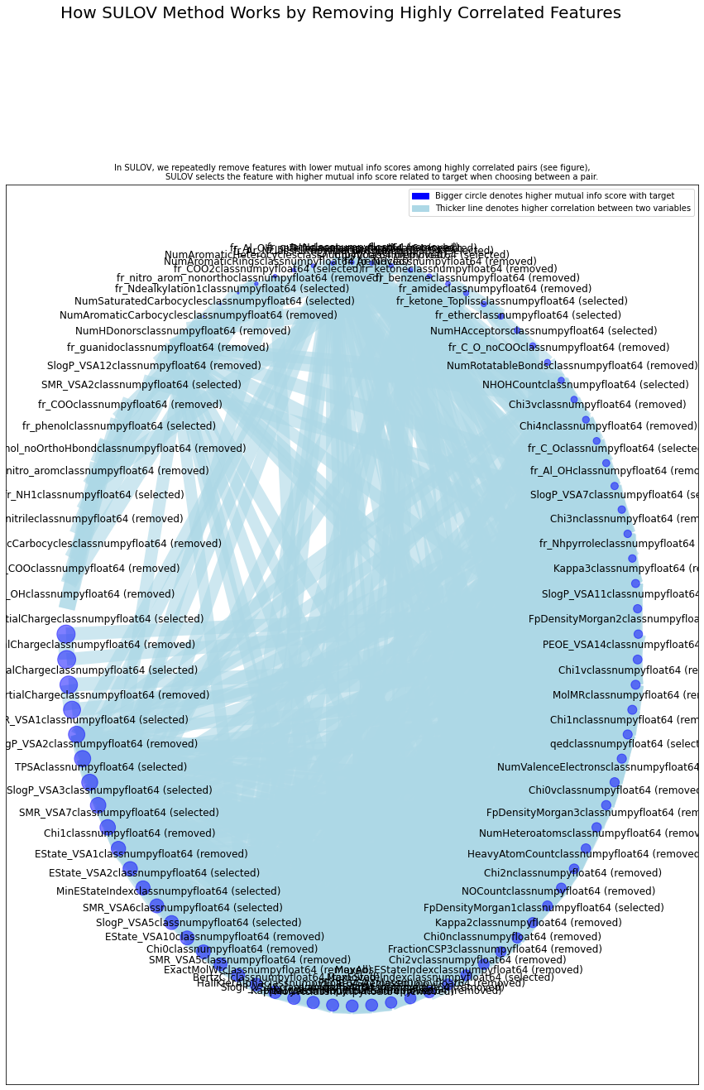

Time taken for SULOV method = 4 seconds  
 Adding 0 categorical variables to reduced numeric variables of 105  
Final list of selected vars after SULOV = 105  
Readying dataset for Recursive XGBoost by converting all features to numeric...  
#######################################################################################  
##### R E C U R S I V E X G B O O S T : F E A T U R E S E L E C T I O N #######  
#######################################################################################  
 using regular XGBoost  
Train and Test loaded into Dask dataframes successfully after feature_engg completed  
Current number of predictors = 105   
 XGBoost version: 1.6.1  
Number of booster rounds = 100  
 using 105 variables...  
 Time taken for regular XGBoost feature selection = 2 seconds  
 using 84 variables...  
 Time taken for regular XGBoost feature selection = 5 seconds  
 using 63 variables...  
 Time taken for regular XGBoost feature selection = 7 seconds  
 using 42 variables...  
 Time taken for regular XGBoost feature selection = 8 seconds  
 using 21 variables...  
 Time taken for regular XGBoost feature selection = 9 seconds

Total time taken for XGBoost feature selection = 12 seconds  
#######################################################################################  
##### F E A T U R E S E L E C T I O N C O M P L E T E D #######  
#######################################################################################  
Selected 56 important features. Too many to print...  
  
 Time taken for feature selection = 15 seconds  
Returning 2 dataframes: dataname and test_data with 56 important features.  
 Time taken to create entire pipeline = 17 second(s)

["('fr_NH2', <class 'numpy.float64'>)",  
 "('fr_ester', <class 'numpy.float64'>)",  
 "('fr_pyridine', <class 'numpy.float64'>)",  
 "('NumSaturatedRings', <class 'numpy.float64'>)",  
 "('fr_piperzine', <class 'numpy.float64'>)",  
 "('fr_C_O', <class 'numpy.float64'>)",  
 "('MaxEStateIndex', <class 'numpy.float64'>)",  
 "('SlogP_VSA8', <class 'numpy.float64'>)",  
 "('TPSA', <class 'numpy.float64'>)",  
 "('NumSaturatedCarbocycles', <class 'numpy.float64'>)",  
 "('PEOE_VSA4', <class 'numpy.float64'>)",  
 "('SMR_VSA10', <class 'numpy.float64'>)",  
 "('fr_aryl_methyl', <class 'numpy.float64'>)",  
 "('NumHAcceptors', <class 'numpy.float64'>)",  
 "('MinEStateIndex', <class 'numpy.float64'>)",  
 "('SlogP_VSA5', <class 'numpy.float64'>)",  
 "('MaxPartialCharge', <class 'numpy.float64'>)",  
 "('SlogP_VSA4', <class 'numpy.float64'>)",  
 "('VSA_EState10', <class 'numpy.float64'>)",  
 "('PEOE_VSA12', <class 'numpy.float64'>)",  
 "('SlogP_VSA1', <class 'numpy.float64'>)",  
 "('PEOE_VSA11', <class 'numpy.float64'>)",  
 "('PEOE_VSA2', <class 'numpy.float64'>)",  
 "('SMR_VSA6', <class 'numpy.float64'>)",  
 "('fr_bicyclic', <class 'numpy.float64'>)",  
 "('RingCount', <class 'numpy.float64'>)",  
 "('fr_Imine', <class 'numpy.float64'>)",  
 "('PEOE_VSA5', <class 'numpy.float64'>)",  
 "('fr_phenol', <class 'numpy.float64'>)",  
 "('fr_NH0', <class 'numpy.float64'>)",  
 "('fr_para_hydroxylation', <class 'numpy.float64'>)",  
 "('fr_allylic_oxid', <class 'numpy.float64'>)",  
 "('fr_sulfone', <class 'numpy.float64'>)",  
 "('fr_Ar_N', <class 'numpy.float64'>)",  
 "('fr_Ndealkylation1', <class 'numpy.float64'>)",  
 "('fr_aniline', <class 'numpy.float64'>)",  
 "('fr_Ndealkylation2', <class 'numpy.float64'>)",  
 "('fr_oxazole', <class 'numpy.float64'>)",  
 "('fr_imidazole', <class 'numpy.float64'>)",  
 "('qed', <class 'numpy.float64'>)",  
 "('fr_unbrch_alkane', <class 'numpy.float64'>)",  
 "('fr_sulfide', <class 'numpy.float64'>)",  
 "('SlogP_VSA3', <class 'numpy.float64'>)",  
 "('SMR_VSA7', <class 'numpy.float64'>)",  
 "('MaxAbsPartialCharge', <class 'numpy.float64'>)",  
 "('NHOHCount', <class 'numpy.float64'>)",  
 "('Chi4v', <class 'numpy.float64'>)",  
 "('SMR_VSA1', <class 'numpy.float64'>)",  
 "('fr_ketone_Topliss', <class 'numpy.float64'>)",  
 "('fr_NH1', <class 'numpy.float64'>)",  
 "('fr_ether', <class 'numpy.float64'>)",  
 "('FpDensityMorgan1', <class 'numpy.float64'>)",  
 "('SlogP_VSA7', <class 'numpy.float64'>)",  
 "('fr_COO2', <class 'numpy.float64'>)",  
 "('SMR_VSA2', <class 'numpy.float64'>)",  
 "('fr_Nhpyrrole', <class 'numpy.float64'>)"]

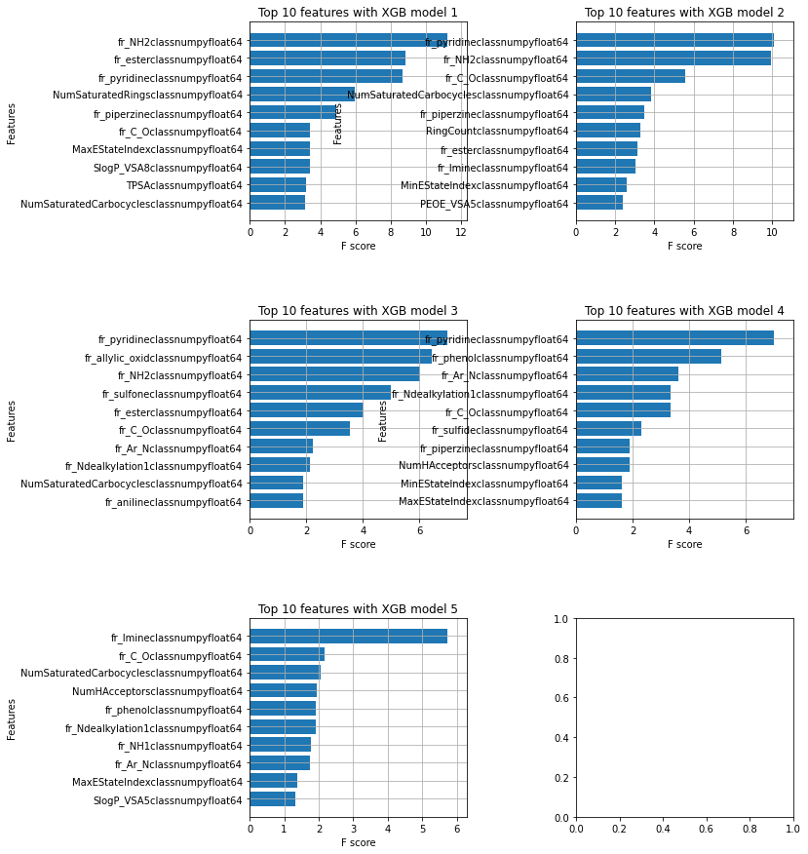

It should be noted that the feature selection section is processed**only based on the information in the training set.**

**56** features were selected as influencing features on the target variable in the Bace dataset**.**

**PCA**

I have used PCA but the result of our model is not good in this way, cause of that ignored it.

**from** sklearn.decomposition **import** PCA **as** sklearnPCA

pca **=** sklearnPCA(n_components**=**40)

pca**.**fit(X_train)

X_train**=**pca**.**transform(X_train)

X_test**=**pca**.**transform(X_test)

plt**.**plot(np**.**arange(40),pca**.**explained_variance_ratio_)

plt**.**show()

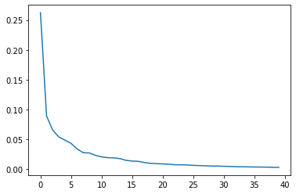

**Scailing data**

from sklearn.preprocessing import StandardScaler

from sklearn.model_selection import train_test_split

from sklearn import preprocessing

import random

np.random.seed(1234)

from sklearn import preprocessing

scaler_data = preprocessing.MinMaxScaler()

X_train = scaler_data.fit_transform(X_train)

X_test = scaler_data.transform(X_test)

scaler_labels = preprocessing.MinMaxScaler()

**I have not used MinMaxScaler method on lables, because they are 0 or 1.**

**Transform** **to** **torch** **tensor**

device = torch.device('cuda:0' if torch.cuda.is_available() else 'cpu')

tensor_x = torch.tensor(X_train, dtype=torch.float).to(device)

tensor_x2 = torch.tensor(X_test, dtype=torch.float).to(device)

tensor_y = torch.tensor(Y_train, dtype=torch.float).to(device)

tensor_y2 = torch.tensor(Y_test, dtype=torch.float).to(device)

# create your dataset

trainset = TensorDataset(tensor_x, tensor_y)

testset = TensorDataset(tensor_x2,tensor_y2)

**Loading the Data**

def load_data(data_dir=None):

    return trainset, testset

### **Missing values**

Bace data set has not any missing values.

### **Accuracy and error measurement**

I used ROC_AUC score for Bace data set ,cause that is a classification project.

from sklearn.metrics import roc_auc_score

def compute_score(model, data_loader, device="cpu"):

    model.eval()

    metric = roc_auc_score

    with torch.no_grad():

        prediction_all= torch.empty(0, device=device)

        labels_all= torch.empty(0, device=device)

        for i, (feats, labels) in enumerate(data_loader):

            feats=feats.to(device)

            labels=labels.to(device)

            prediction = model(feats).to(device)

            prediction = torch.sigmoid(prediction).to(device)

            prediction_all = torch.cat((prediction_all, prediction), 0)

            labels_all = torch.cat((labels_all, labels), 0)

        try:

            t = metric(labels_all.int().cpu(), prediction_all.cpu()).item()

        except ValueError:

            t = 0

    return t